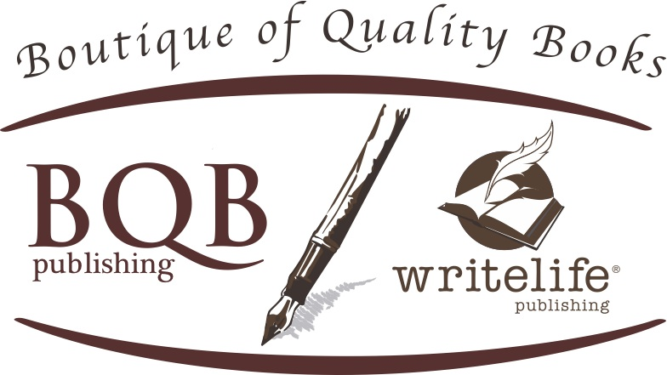
terri@bqbpublishing.com
www.bqbpublishing.com
678-316-4150

Biography for Erica Witsell

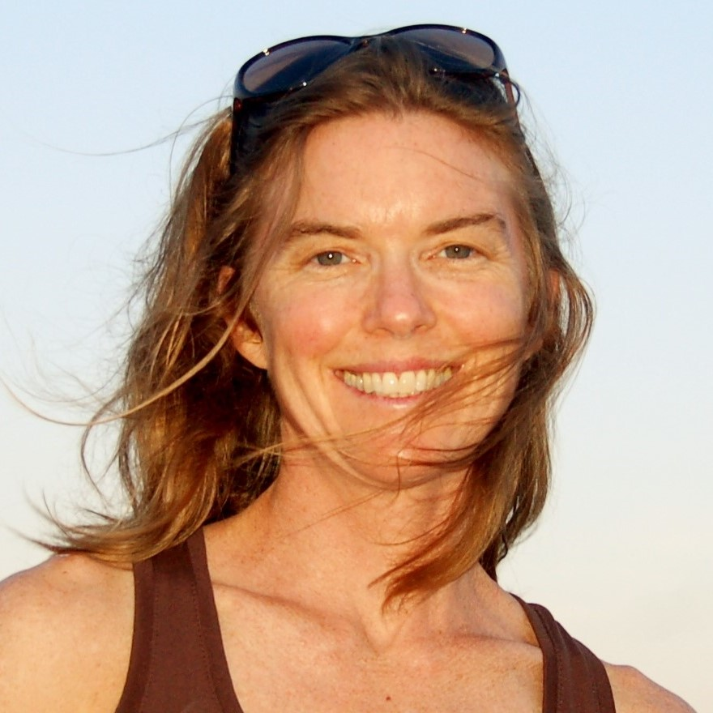
Erica Witsell has a bachelor's degree from Wesleyan University and a master's from UC Berkeley. Her writing has appeared in The Sun Magazine, and Brain, Child's online publication. Give is her debut novel.

Erica lives in western North Carolina with her family, where she teaches English as a new language and writes a blog about motherhood. She loves mountains, languages, bicycling, and dance.

Visit her online at www.ericawitsell.com

