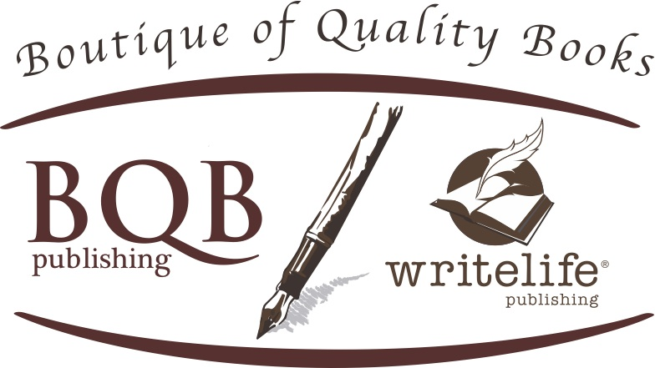

960 Oaktree Boulevard
Christiansburg, VA 24073
terri@bqbpublishing.com

ENDORSEMENTS FOR GIVE, A NOVEL

- “Give is a striking, often unflinching, depiction of a doomed marriage and its enduring consequences. Erica Witsell is a very talented writer and her debut should garner a wide and appreciative audience.”
– Ron Rash, author of the 2009 PEN/Faulkner Finalist and New York Times bestselling novel Serena, in addition to four other prizewinning novels

- “A very unusual family saga written with unusual intelligence and compassion. Erica Witsell has a gift for depicting complex relationships.”
– Phyllis Rose, author of Parallel Lives, Jazz Cleopatra, and The Shelf

- “At times subtle and at times cutting to the quick, Give digs deep into the heart and soul of a family as connected as it is torn apart. Give pulls no punches, delivering an honest look into the lengths we will go for family.”
– Amy Willoughby-Burle, author of The Lemonade Year

- “This is a gripping narrative about family, identity, and loyalty. The themes are both uniquely modern and timeless. I fell in love with the characters as they struggled to understand themselves and reconcile with one another. Beautifully written!”
– Kate Rademacher, author of Following the Red Bird
- "[A] lovely coming of age story that shows an honest portrait of a family that loves each other but may not always know the best ways to show it. "
– Andrea, Fountain Bookstore, Richmond, VA

- "Erica Witsell's debut novel is a treasure. What makes it a treasure is how it tells the story of a family not that different from yours or mine, in a way that keeps pulling you back, page after page, chapter after chapter. . . Erica is a superb story teller, and her book deserves to be read by as many book lovers as possible."
– Jon Mayes, Advanced Reading Copy

- ". . . Witsell's prose is both lyrical and believable, particularly in her authentic and honest dialogue between women. In its earnest, unrestrained exploration of sisterhood, Give is a groundbreaking approach to the timeless themes of loss, love, and loyalty."
– News @ Wesleyan, You Just Have to Read This Book

- “This is an engrossing novel about family and forgiveness. Tracing the lives of five characters over the span of thirty years, Erica C. Witsell shows us that family is about choice as much as it is about blood and that sacrifice and selfishness both play a role in how we parent and love.”
– Sarah Viren, author of Mine

